Capstone Project - The Battle of Neighborhoods

Opening a Thai Restaurant in Colombo, Sri Lanka

1. **Introduction**
   1. **Background**

Colombo is the commercial and largest city of Sri Lanka by population. Also refer as the Commercial Capital of Sri Lanka. According to the Brookings Institution, Colombo metropolitan area has a population of 5.6 million and 752,993 in the City. Colombo is a multi-religious, multi-ethnic, multi-cultural city, and divided into 15 numbered areas for the purposes of postal services. Postal numbers and the City Districts (neighborhoods) are as below [1]:

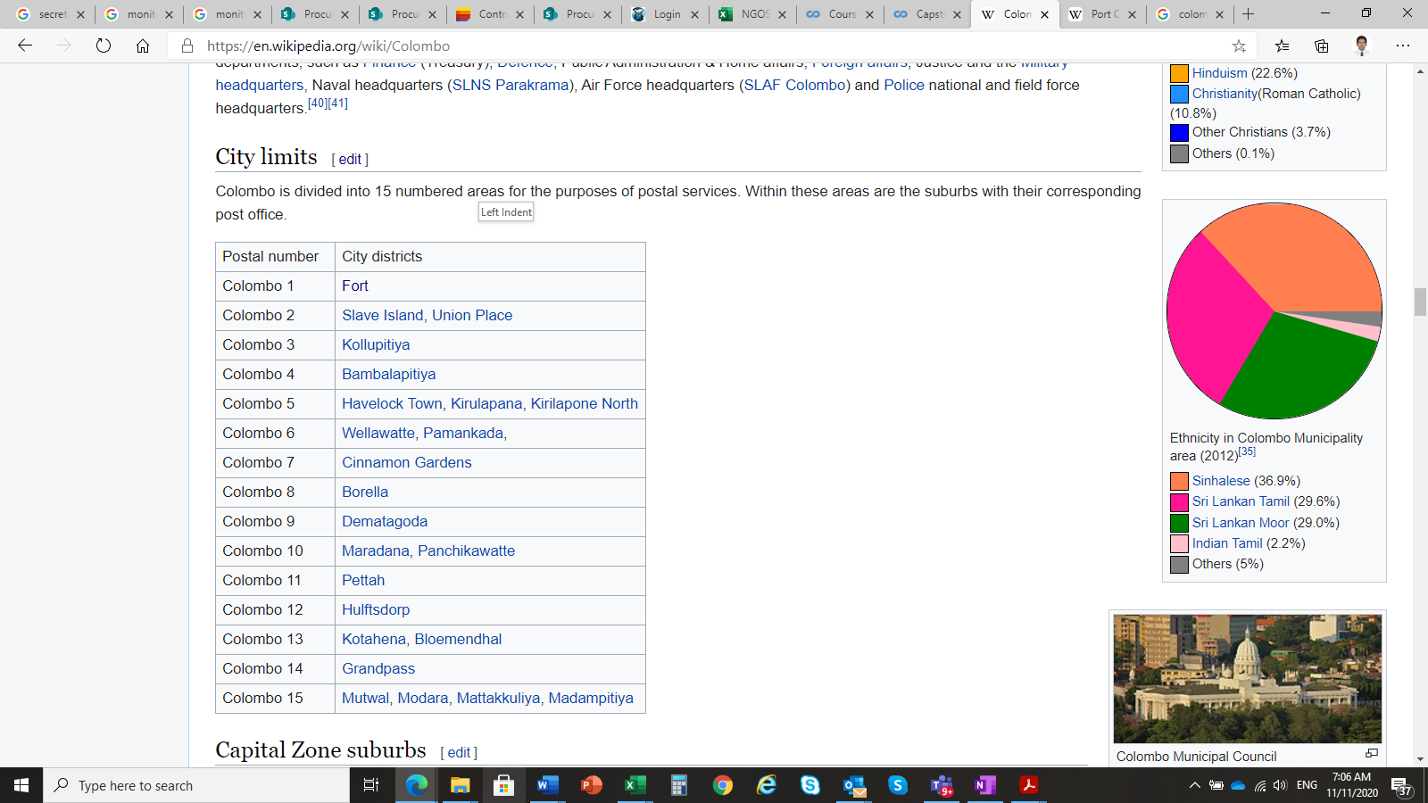

*The Colombo Metropolitan area has a GDP (PPP) of $122 billion or 40% of the GDP, making it the most important aspect of the Sri Lankan economy. The per capita income of Colombo Metro area stood at US$8623 and purchasing power per capita of $25,117, making it one of the most prosperous regions in South Asia. The Colombo Metropolitan (CM) area is the most important industrial, commercial and administrative centre in Sri Lanka. A major share of the country's export-oriented manufacturing takes place in the CM area which is the engine of growth for Sri Lanka.* [1]

Due its harbor and the strategic position along the East–West sea trade routes, Colombo has been known for trade more 2000 years. Currently harbor has expanded its capacity to handle large amount of cargo vessels in a day. In addition, Port City is under construction on reclaimed land adjacent to the port and will be developed as the special financial zone and International Financial Centre in Colombo. Majority of cooperate offices, hotels, restaurants and entertainment venues are in the city. New high-rise buildings are developing in the city with apartments, offices and shopping malls. These new add-ons will boost up the economy of the city as well as the country. It also majorly contributes to the ambition of Government of Sri Lanka to become the economic hub in the South Asian region. Due to developing environment and boosting economy, it will be good opportunity to the investors to open their business in the city area.

* 1. **Problem**

It is estimated that around 450,000 cars, vans, three-wheelers, motorcycles and 29,000 mass transit vehicles, mainly buses come into Colombo city carrying 1.8-1.9 million people on a daily basis. Jul 25, 2019 [2]

With the new development in the Colombo city area, becoming the economic hub in the South Asian region and the statistics shown in above, there will be more than two million foreign and local people will be engaged daily in the Colombo City. Due to this increase in population, there is a good demand for food and new opportunities are opening for food related businesses in the city of Colombo.

In this project, I’m focusing on restaurants and will investigate that if there is any good location in Colombo city for opening Thai restaurant and it really values to open one.

1. **Data**
   1. **Source of Data**

Following data was used to achieve the objective of this study.

* Neighborhood data of Colombo city from Wikipedia. [1]
* Python geocoder library to get geographical coordinates of neighborhoods [3]
* Foursquare API venues explore method to get the venues of given neighborhoods of Bucharest [4].
  1. **Use of data to solve the problem**

There are 15 postal areas in the Colombo city. In some postal areas consist more than one neighborhood. So, first step is to obtain location values for each neighborhood from geocoder library and analyze Colombo city geographical structure. To analyze, folium library of python will be used to draw the map of Colombo city and its neighborhoods.

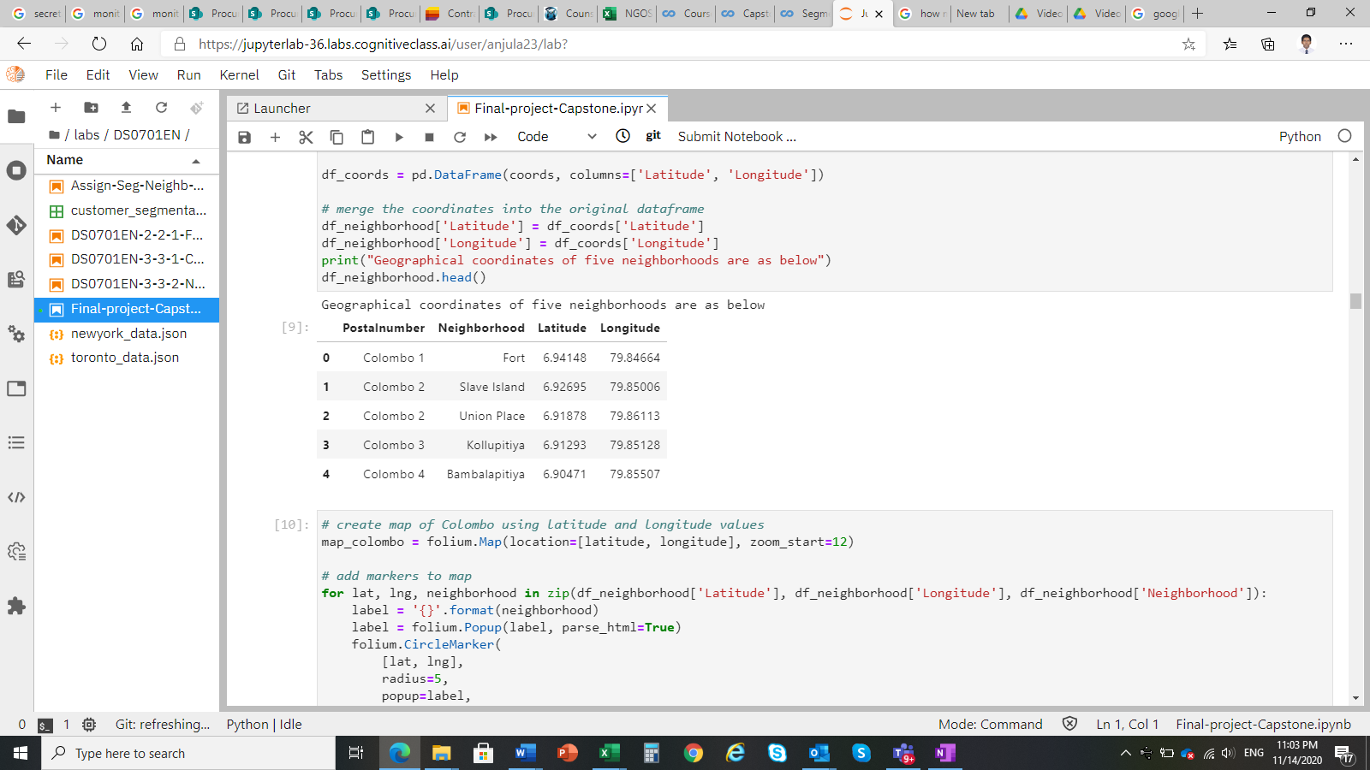

## Then using Foursquare API venues information, obtain each venue, venue category and venue location with respect to each neighborhood.

## 

The restaurants and Thai restaurants details will be extracted from above information to analyze restaurant distribution in neighborhoods.

## Venue distribution will be used to classify neighborhoods. Then analyze the similarities of the neighborhoods to identify locations that suit to open a new Thai restaurant.

## 

## References:

* [1] [Colombo — Wikipedia](https://en.wikipedia.org/wiki/Bucharest)
* [2] [Dailynews article on "Hassle-free travel in Colombo"](https://www.dailynews.lk/2019/07/25/features/192083/hassle-free-travel-colombo#:~:text=It%20is%20estimated%20that%20around,people%20on%20a%20daily%20basis).
* [3] [Python Geocoder Library](https://geocoder.readthedocs.io/)
* [4] [Foursquare API](https://developer.foursquare.com/)

1. **Methodology**
   1. **Examine Colombo City Geographical Structure**

Map of Colombo city was created using folium library of python and 24 neighborhoods locations shows in the figure 1. This indicates that needihoods of North and South part of the Colombo city are closely locate and center neighborhoods have some distance each other.

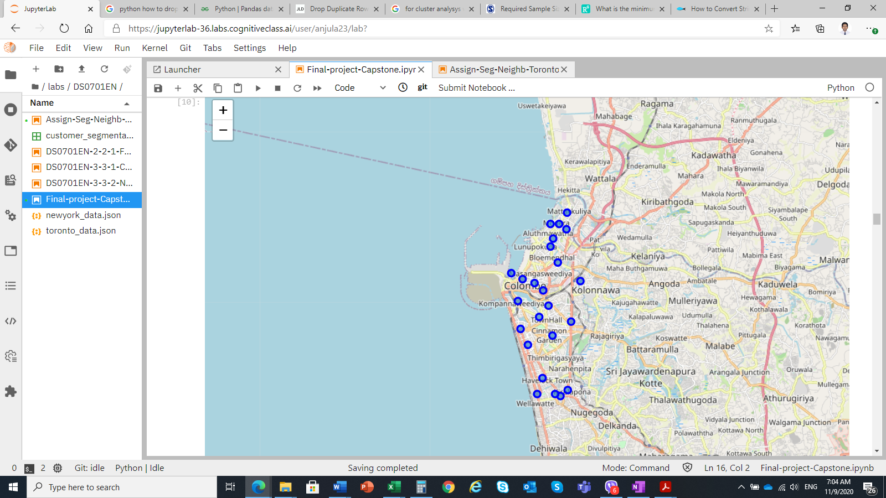

Figure 1: Neighborhoods structure of the Colombo City

* 1. **Examine Venues in Neighborhoods**

Using Foursquare API, maximum of 100 venues and within radius of 750m from each neighborhood were extracted and merged into the neighborhood data. There are 148 unique venue categories in Colombo and top 10 venue counts is given below table.

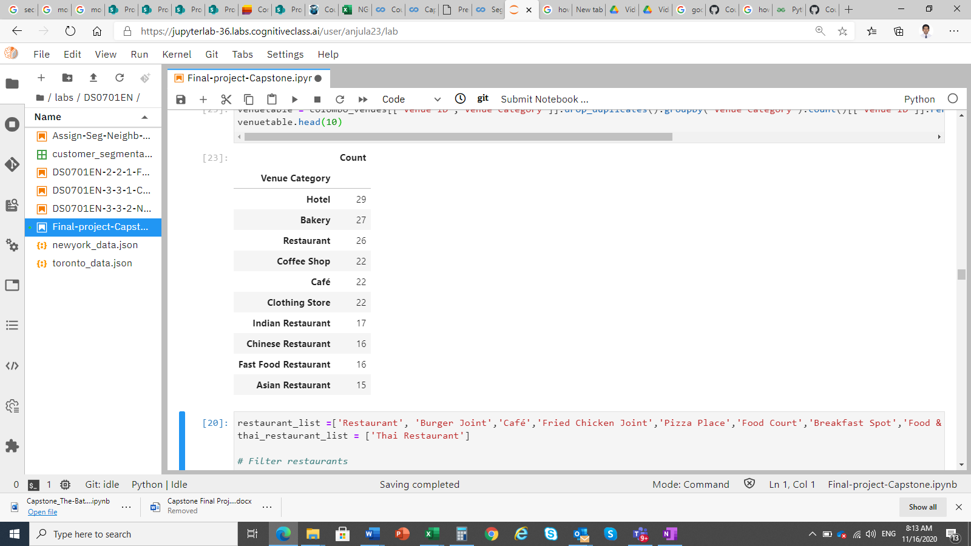

To examine the restaurant type venues, I filtered the venues such as Restaurants, Burger Joints, Cafés, Pizza Places, etc... and take counts for each neighborhood. Below figure 2 indicates that among 24 neighborhoods only 6 have Thai restaurants.

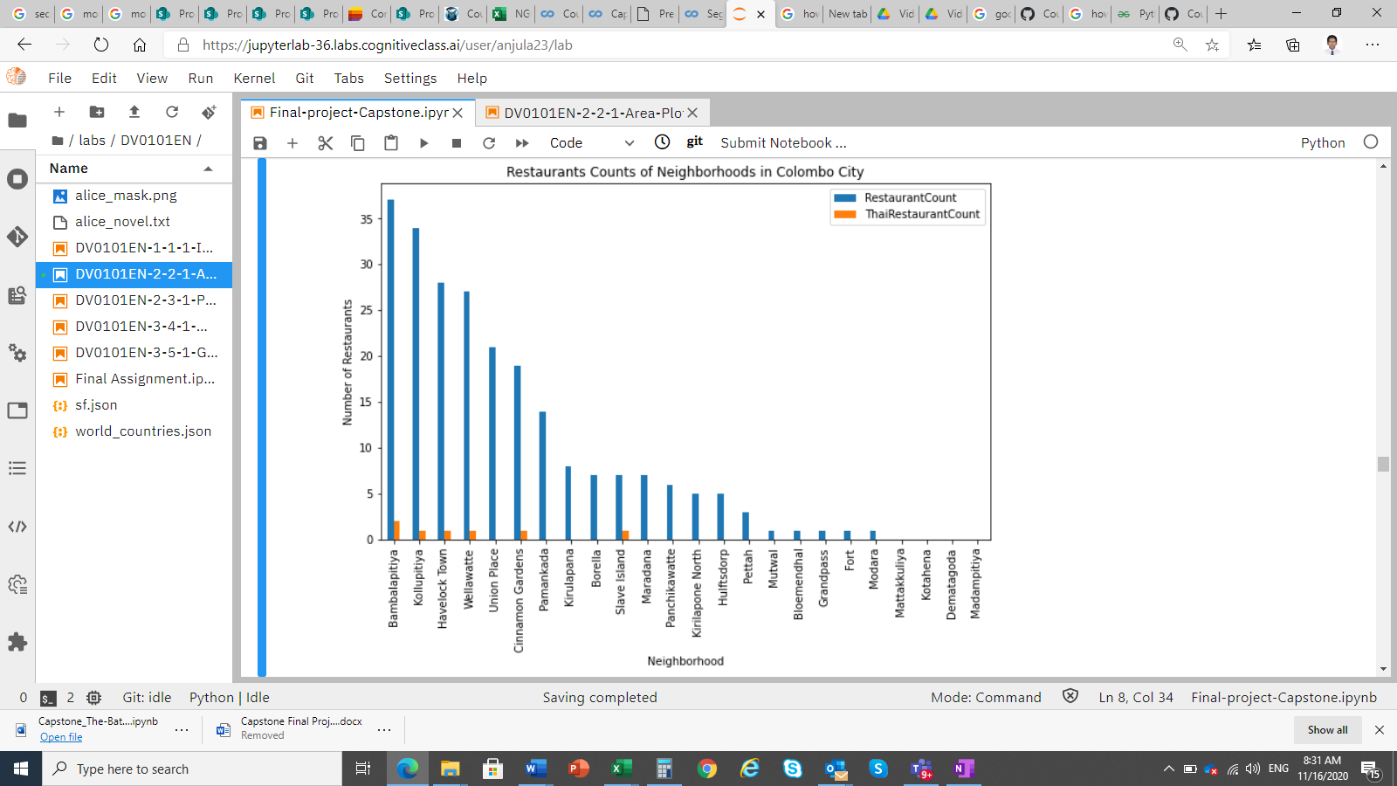

Figure 2: Restaurants and Thai restaurants distribution in Colombo City

Also, below map shows that restaurants (in blue) and Thai restaurants (in red) locate in Colombo district. All the Thai restaurants locate in coastal areas of Colombo city. Only 6 neighborhoods have Thai restaurants. 4 neighborhoods don’t have any restaurant within the 750m radius. Those are Mttiakkuliya, Kotahena, Dematagoda and Madampitiya.

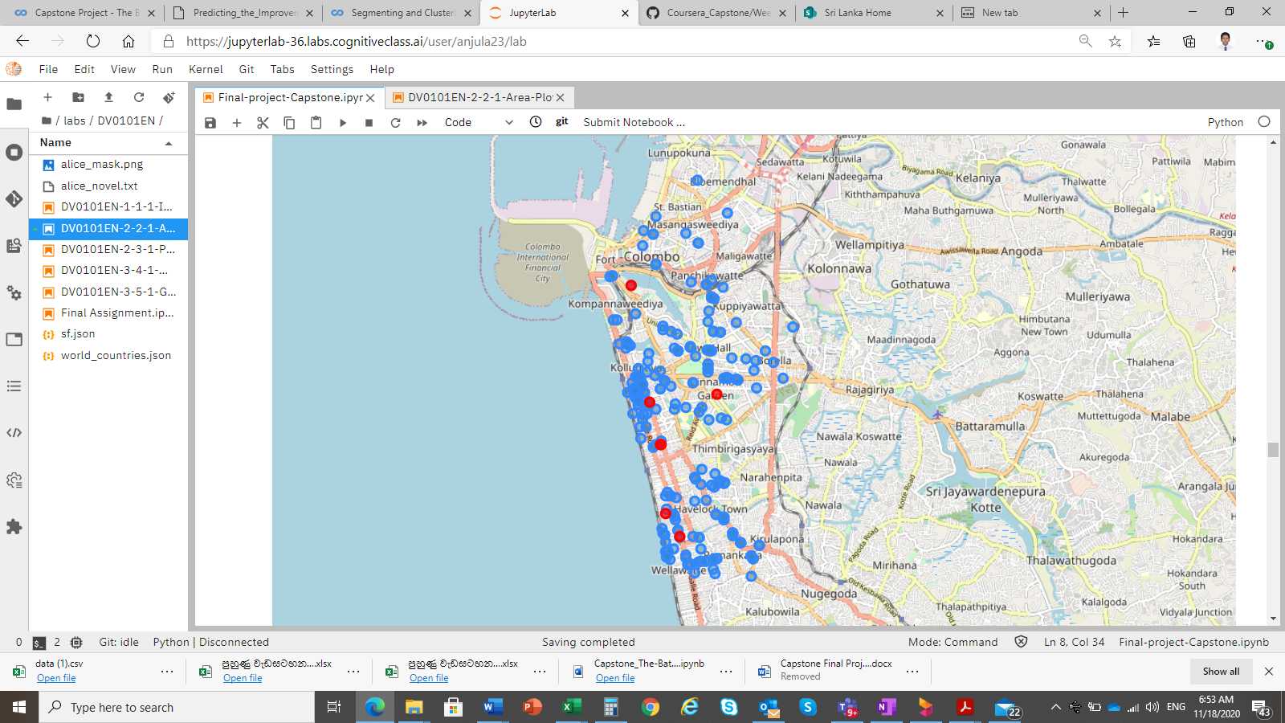

Figure 3: Restaurants structure of the Colombo City

K-means clustering method was used to cluster the neighborhoods according to mean of the frequency of occurring of each category. Decided to separate neighborhoods in to 5 clusters. Below figure 4 indicates the clusters distribution by location.

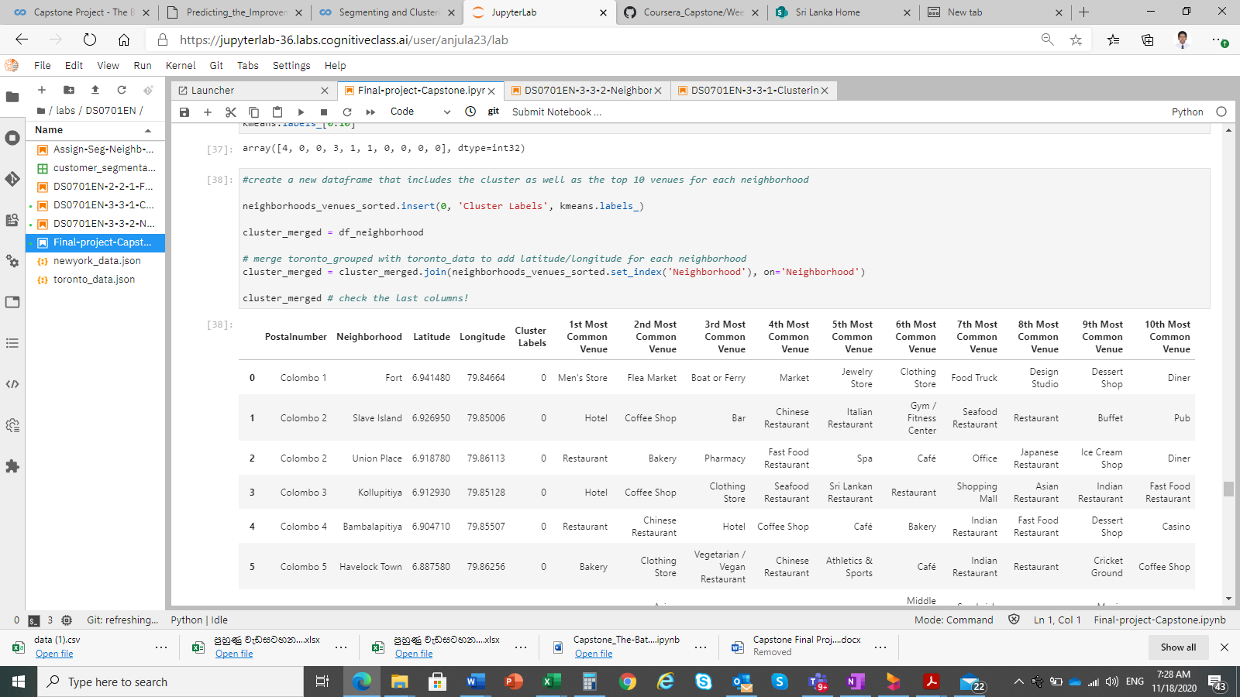

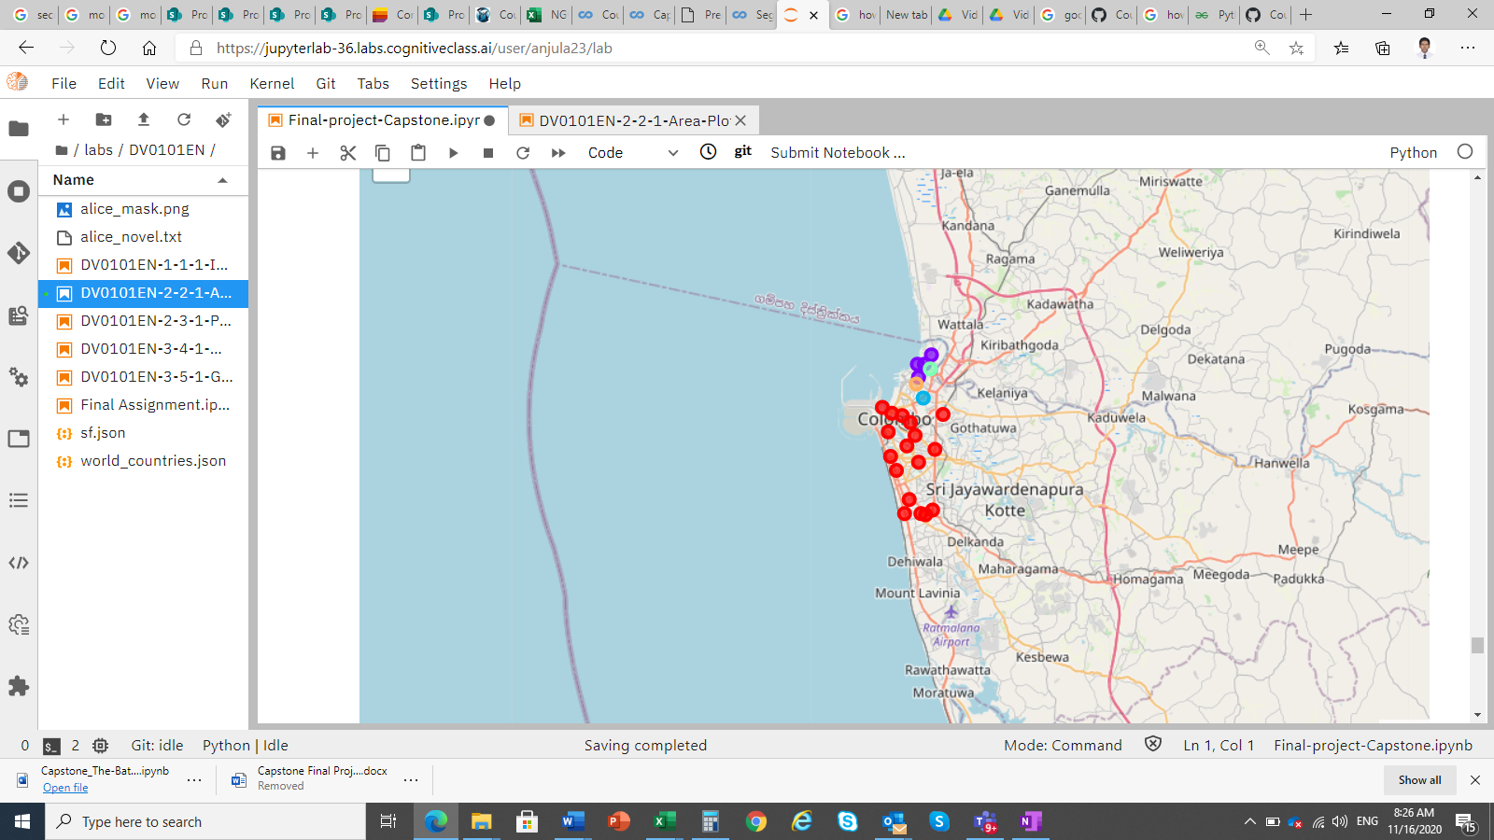

Cluster 0: Red

Cluster 1: Blue

Cluster 2: Purple

Cluster 3: Orange

Cluster 4: Green

Figure 4: Cluster distribution

Below tables show that 1st and 2nd most common venues it each cluster.

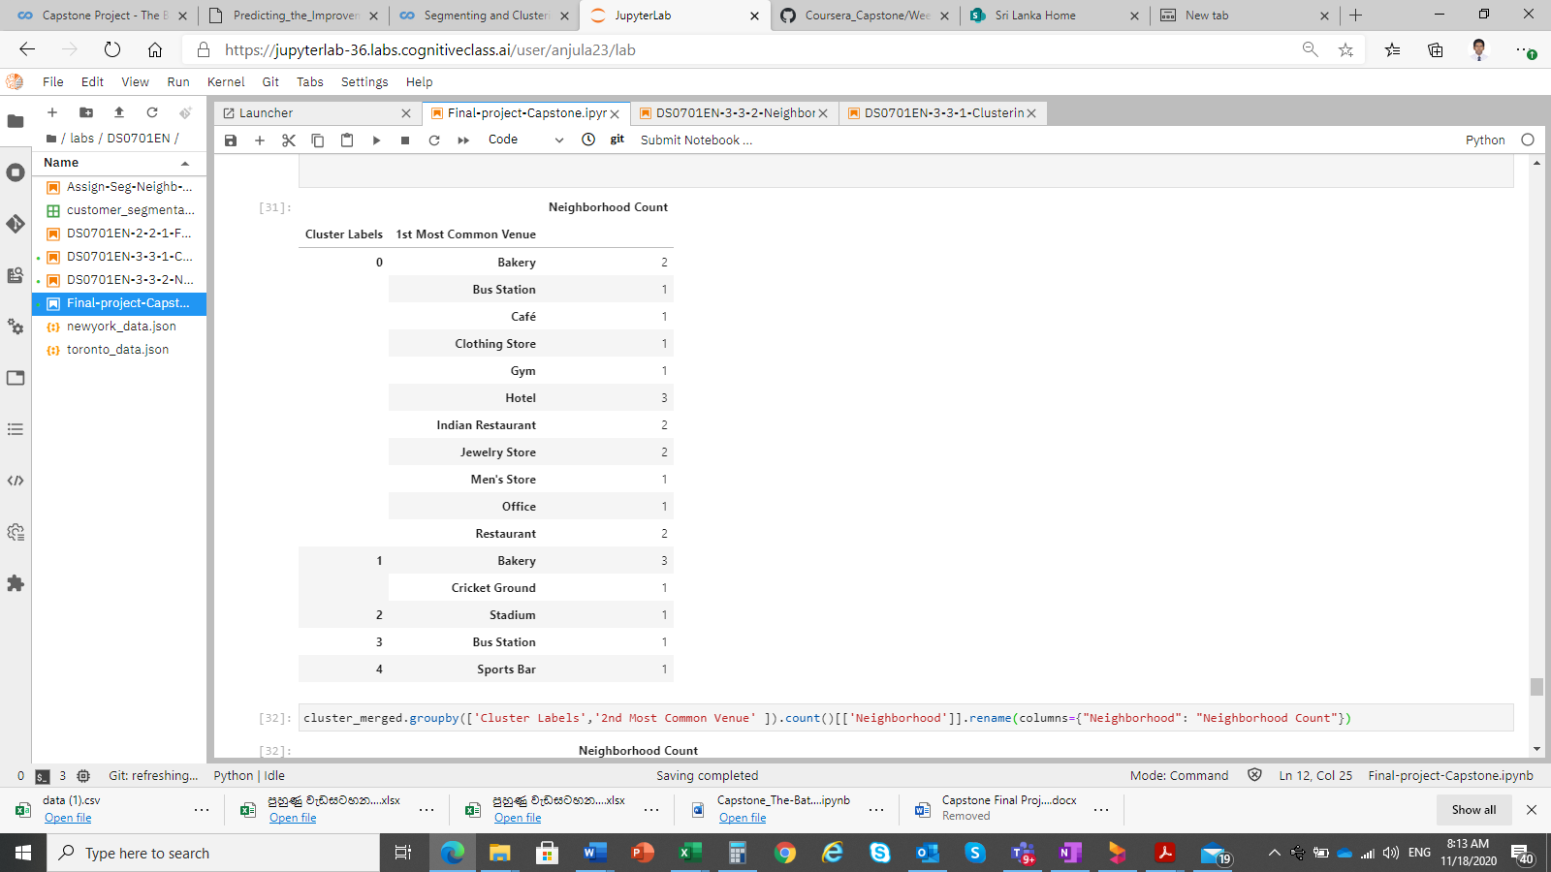 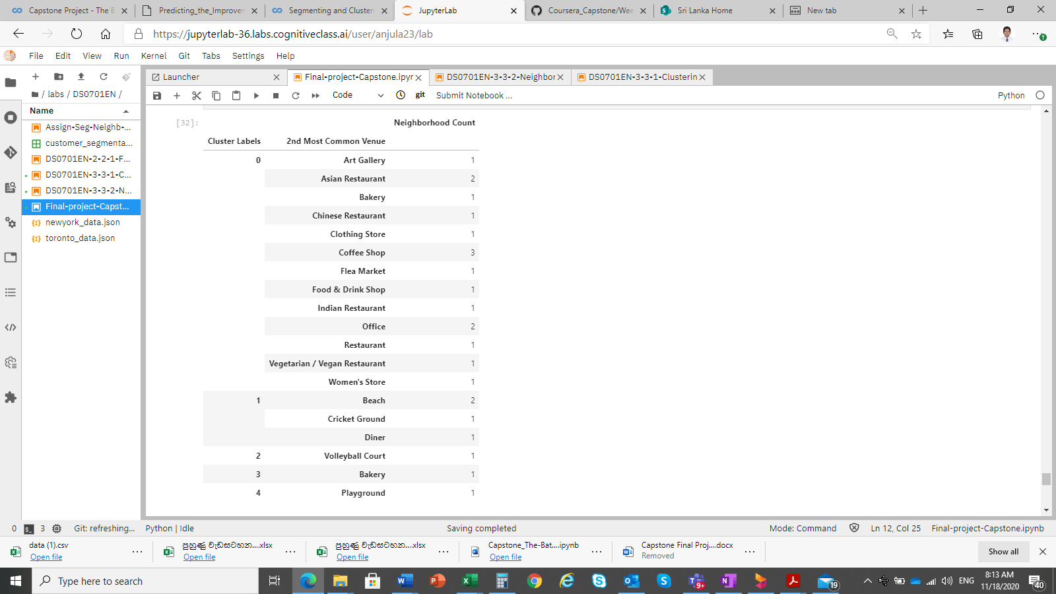

According to cluster segmentation, following venues are common for the each cluster,

Cluster 0: Asian Restaurants, Restaurants, offices, Coffee Shops

Cluster 1: Bakery, Beach, Cricket Ground,

Cluster 2: Stadium, Volleyball Court

Cluster 3: Bakery

Cluster 4: Sports Bar, Play Ground

1. **Results**

Total of 756 venues were extracted and among them 190 venues are food related venues such as Restaurants, Burger Joints, Cafés, Pizza Places, etc... From those restaurant type venues, only 7 Thai restaurants were identified, and it is 3.68% of total restaurant type venues. Those 7 Thai restaurants are located in 6 neighborhoods and other 18 neighborhoods do not have any Thai restaurant.

Bar chart and Figure 3 indicate,

* Center of Colombo such as Bambalapitiya, Kollupitiya, Havelock Town and Cinnamon Gardens are having more restaurants than other areas.
* Southern areas like Wellawatte and Pamankada and Union Place are having high number of restaurants and food related places.
* Even though they have high number of restaurants (more than 10), Union Place and Pamankada areas don’t have Thai restaurants within 750m radius.
* Northern part of the Colombo City is having less restaurants.
* Mattakkuliya, Kotahena, Dematagoda and Madampitiya neighborhoods don’t have any kind of restaurant within the 750m radius.
* Also North East part (Maradana, Panchikawatte and Dematagoda) and East part (Borella) of Colombo City don’t have any Thai restaurants near to their neighborhoods.

Clusters,

* Cluster 0 has more restaurants and offices. All the Thai Restaurants are also in this this cluster.
* Cluster 1 & 3 prefers bakery items
* Cluster 1, 2 & 4 have more sport related venues than other clusters
* Cluster 3 suffers from any restaurant

1. **Discussion**

People in cluster 0 prefers to eat more from outside because of majority of restaurants concentrated on in this area. Also, they specially like the Asian restaurants. Potential area to open a new Thai restaurant specially areas which doesn’t have Thai restaurant.

Clusters 1, 2, 3 and 4 are also potential place because lack restaurant places and no Thai restaurant available in these neighborhoods. Specially Cluster 3 hasn’t any kind of restaurant. But all these clusters are locating close by and we might select one or two places maximum because majority of people are sport lovers and conscious on their fitness.

Also Mattakkuliya, Kotahena, Dematagoda and Madampitiya neighborhoods are suffers from restaurants and none of the areas have restaurants. These neighborhoods have good opportunity to open new restaurant.

1. **Conclusion**

Below are my suggestion neighborhoods according to the above analysis to the person who wants to open new Thai Restaurant in Colombo city.

Considering number of restaurants more than 10, not available of Thai Restaurants and cluster 0, **Union Place** and **Pamankada** neighborhoods are the chosen.

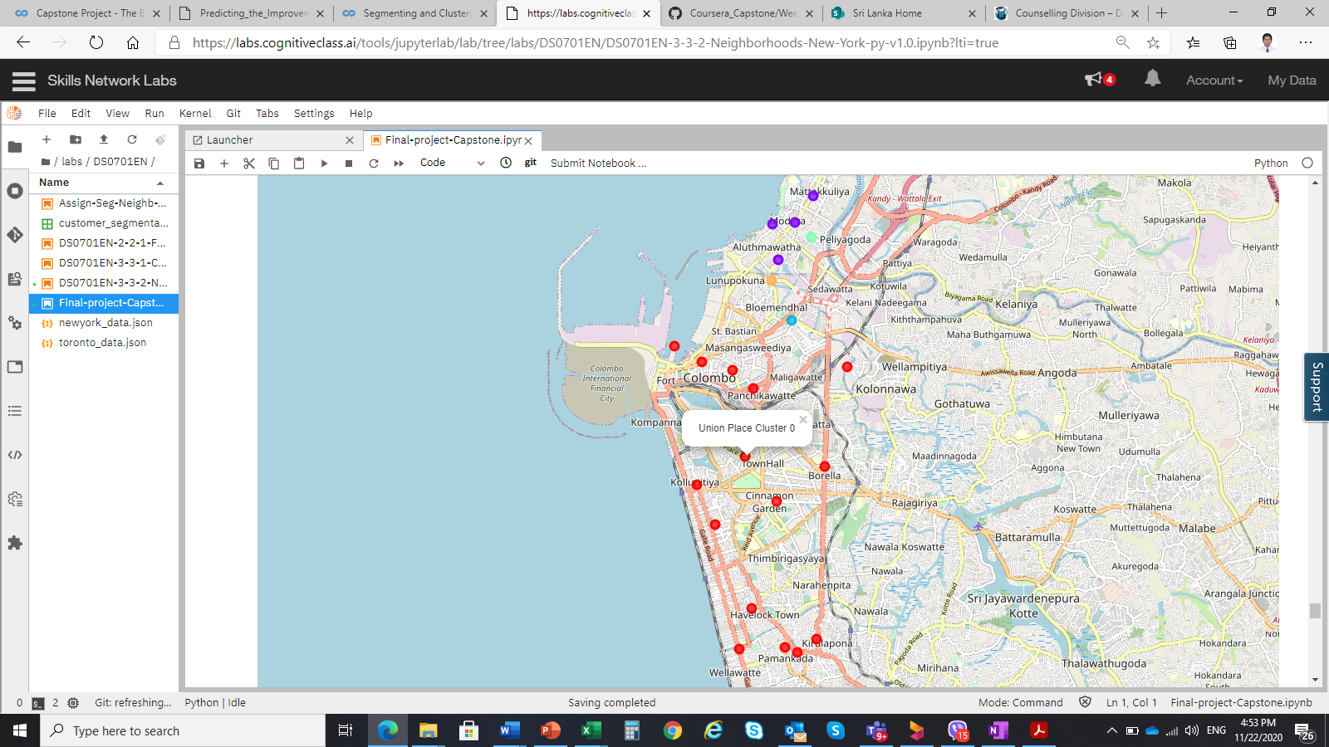 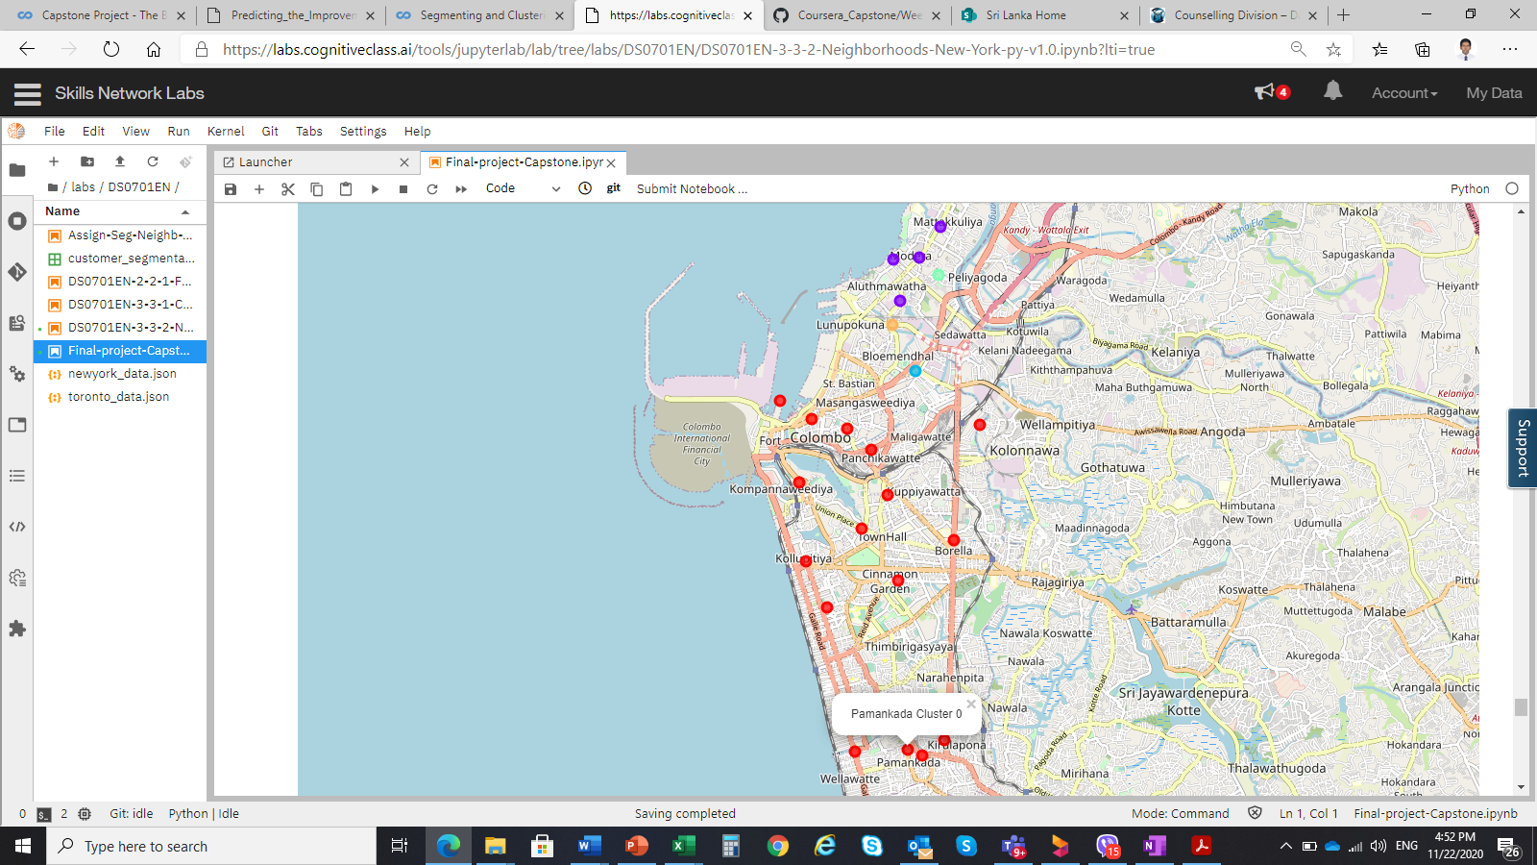

**Madampitiya** is chosen because in that neighborhood suffers from restaurants and among cluster 1,2,3 and 4, this area locates in middle of the clusters. Therefore, Mattakkuliya and Kotahena will ignore because those are close to Madampitiya and within the clusters.

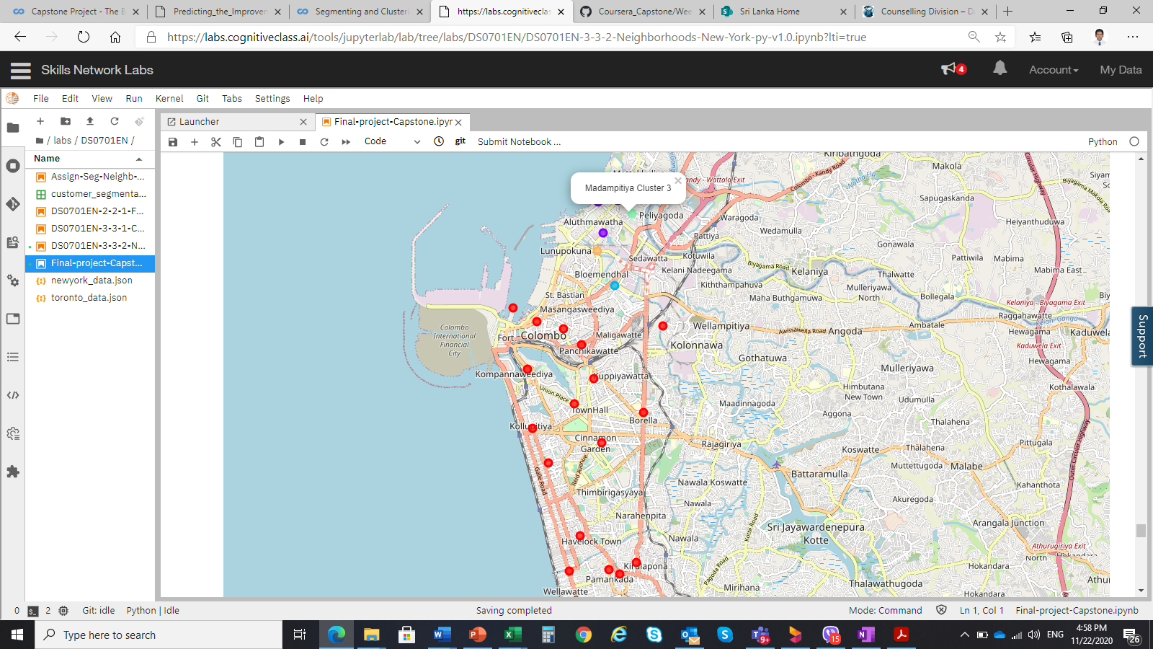

**Dematagoda** is chosen because of no restaurants in the that area, included in cluster 0 which has the people prefer Asian foods and the North East part of the Colombo city.

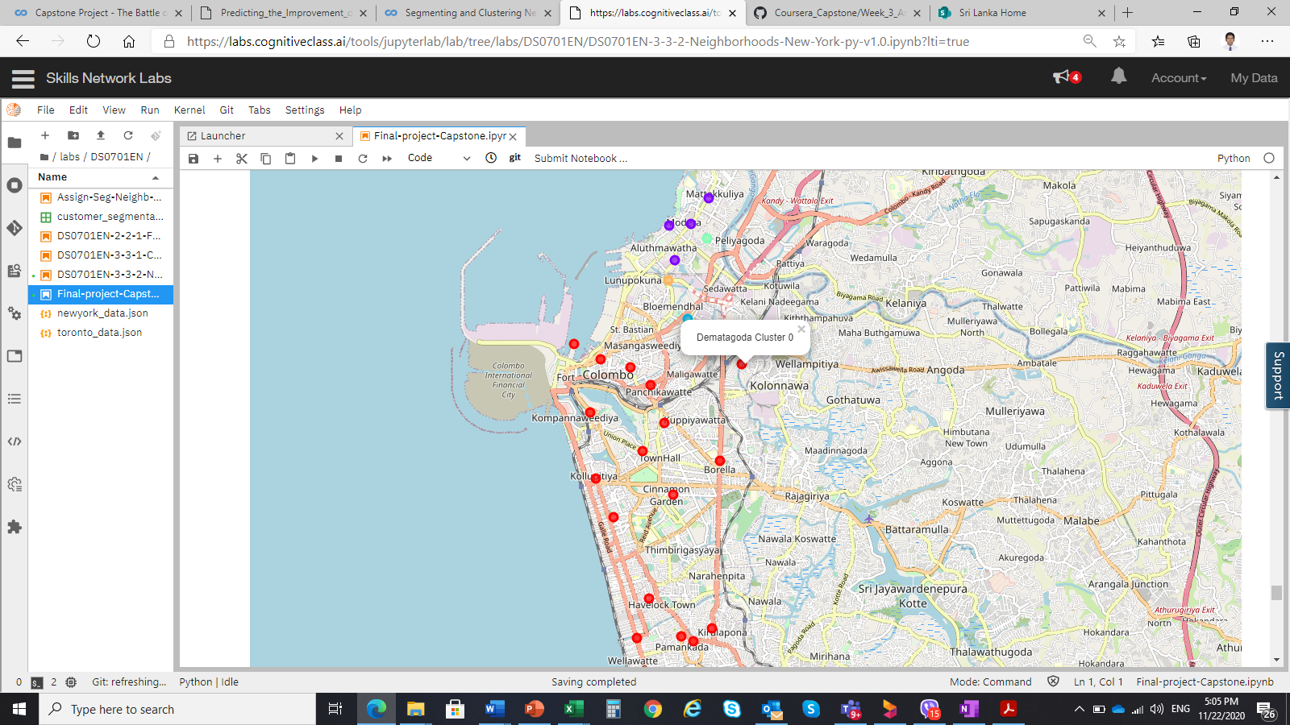 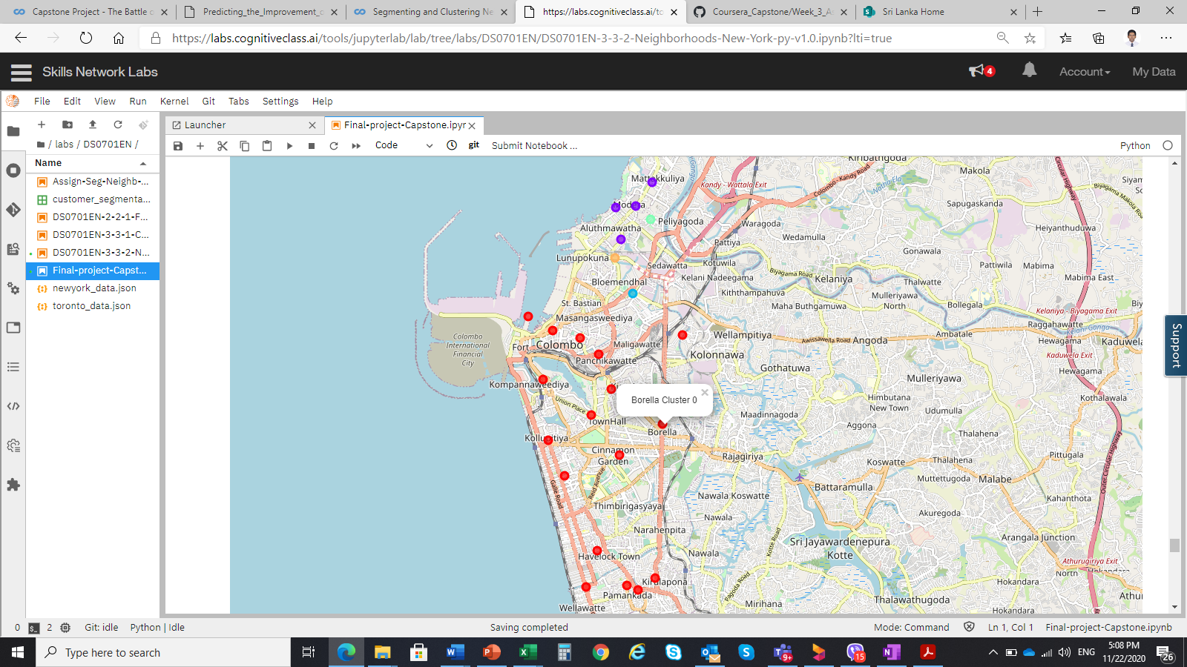

**Borella** is chosen because of no Thai restaurants in the that area, included in cluster 0 which has the people prefer Asian foods and the East part of the Colombo city.